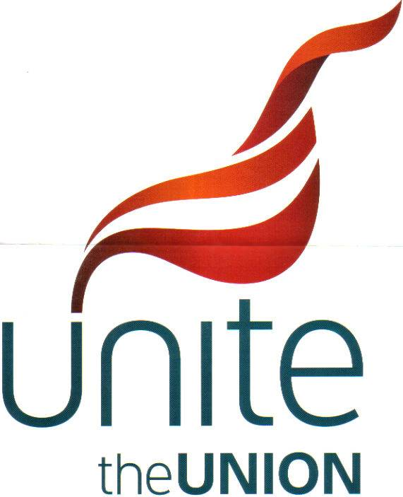
MINUTES FROM BRANCH MEETING ON THE 22.09.21
Agenda Company's pay offer for 2021
Present
L.M. Chair
J.P. V Chair
K.R. Sec
A.H. H&S & Scd.
C.R. Sp. Projects & V.R.
E.B. Eq& Scd
S.B B.R.& V.R.
L.M. opened the meeting at 1900hrs
K.R. read out to the floor the company pay offer for 2021 dated 22 September 21 after a short discussion a vote was called for on this matter and after counting the votes done by proxy and a show of hands by those present the company offer was rejected 100%
L.M. to inform the company of the members decision
We will wait for the company's responce and inform the members when we have one
There being no other matters the meeting was closed at 19.20 hrs

